

**Patient Matching System**

|  |
| --- |
|  |

**User’s Manual**

**REQUIREMENTS:**

**RECOMMENDED BROWSERS**

Patient Matching system supports the following Web Browser:

* Google Chrome Version 64 and above

**SYSTEM OVERVIEW**

Our Patient Matching system is an appointment scheduling system that uses OptaPlanner to match depressed patients with mental health practitioners. The system is fully automated and optimizes the limited mental health resources in the community to meet the needs of depressed patients.

Trying to find the right treatment for depression in the local mental health service landscape can be challenging. We want to assist patients to receive treatment as quickly and conveniently through our system.

Our system makes it easier for a patient to get treatment by compiling a list of the available mental health services in Singapore. The system will consider the severity of the patient’s depression, patients’ spoken language, availability of practitioners, the preferences of patients and treatment costs to schedule appointments. Patients can choose their preferences for the day of the appointment, where the practitioners are located, and gender of the practitioners. Our system will also aim to keep treatment costs down while scheduling the appointments.

**USER INTERFACE**

Our user interface runs in Java web. The web interface displays the results of optimizing the scheduling of patients’ appointment.

**DEPLOYMENT**

Our application runs in Java with OptaPlanner and KIE platform.

For KIE platform

Project File

* Download the project zip file /SystemCodes/PHQTimeTable.zip from GitHub at https://github.com/francis-han/IRS-RS-2019-03-09-IS1PT-GRP-Pepper-PatientMatchingSystem.
* It is best to run the project on JBPM 7.16, the link is /Miscellaneous/LINK_yo_JBPM7_16.

Deployment

* In KIE, create a space “PHQTimeTable”.
* Import the project into the space created.
* Deploy the project.

Process Flow

* Deploy and run the API command using Postman
* The API command consists of three steps:
  + PUT the setting to set the solver
  + POST the data to the solver
  + Wait for one to three minutes for results
  + GET the results

For standalone application – Programme Flow

In order to run the system, you need Java 8 or later versions to be installed.

To run our system, type the command “java -jar rs-patientmatching.0.1.0.jar”.

Open your preferred browser and go to the URL “http://localhost:8090/” as shown below:

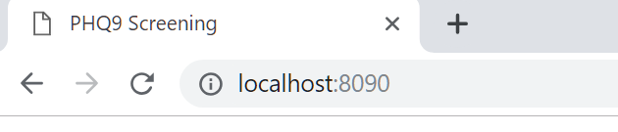

We will be using Google Chrome version 72 (64-bit).

On the main page, the user will be able to click on four options (see figure 1):

1. Show Patients’ Data
2. Show Practitioners’ Data
3. Go to Matching
4. Start PHQ9 Screening

Patients’ data & Practitioners’ data

Both the patients’ and practitioners’ data are existing information stored in our system database. OptaPlanner uses certain patients’ data and practitioners’ data to schedule appointments.

Figure 1. Main page

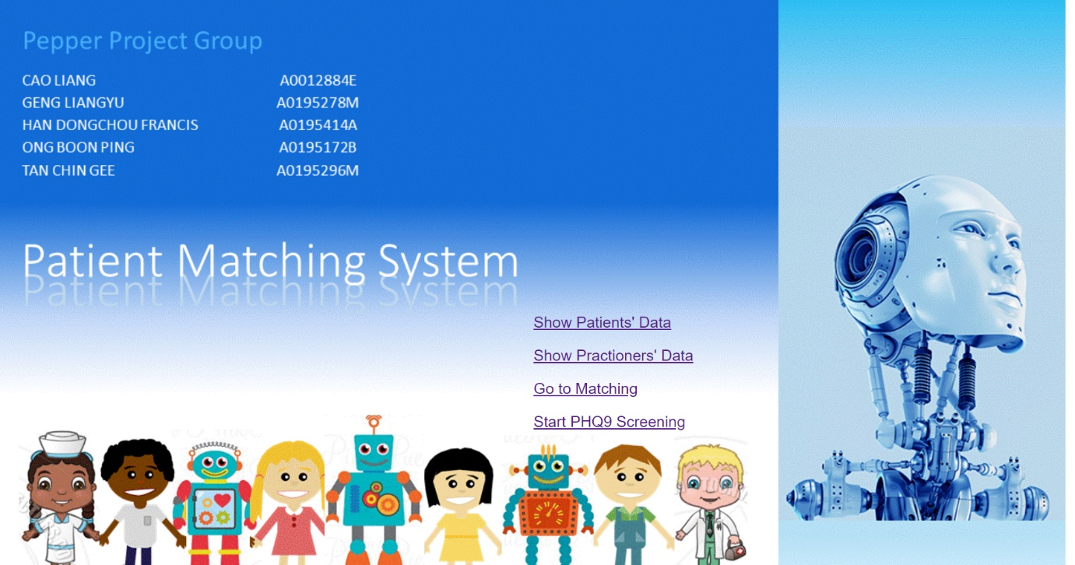

Patients’ data (see figure 2)

Our system captures patients’ data in a database and these data are:

1. **Serial number** – Patient’s serial number increases with each patient added to the record
2. **PHQ-9 score** – A score of the severity of depression which range from 0 to 27, i.e., from no depression to severe depression
3. **Type of practitioners** – Three type of practitioners, counsellor, psychologist, and psychiatrist that is determined by PHQ-9 score:
   1. score between 10 to 14 to counsellor
   2. score between 15 to 19 to psychologist
   3. score between 20 to 27 to psychiatrist
4. **Patient’s language preference** – Patients can indicate one of five language options:
   1. Chinese
   2. English
   3. Malay
   4. Tamil
   5. No preference
5. **Patient’s gender preference** – Patients can indicate one of three options:
   1. Female
   2. Male
   3. No preference
6. **Patient’s location preference** – Patients can indicate one of six options:
   1. Central
   2. East
   3. North
   4. Northeast
   5. West
   6. No preference
7. **Patient’s preferred day** – Patients can indicate one of seven options:
   1. Monday
   2. Tuesday
   3. Wednesday
   4. Thursday
   5. Friday
   6. Saturday
   7. Sunday

Users can return to the main page at any time.

Figure 2. Patients’ data

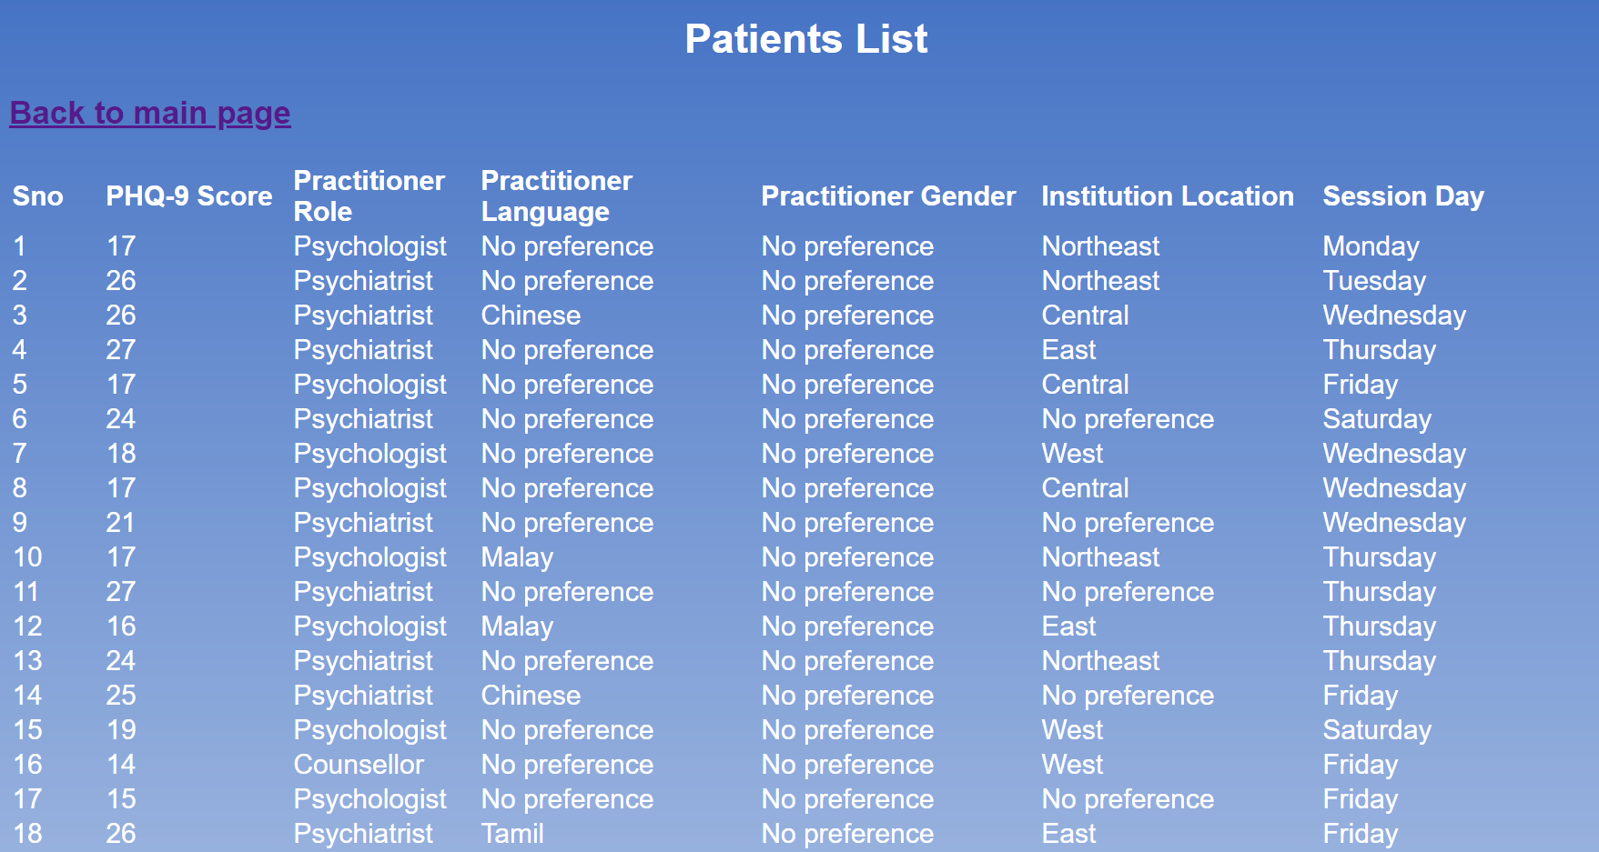

Practitioners’ data (see figure 3)

Our system captures practitioners’ data in a database and these data are:

1. **Serial number** – Practitioner’s serial number increases with each practitioner added to the record
2. **Practitioner’s name** – Salutation and name
3. **Practitioner’s role** – Values can be counsellor, psychologist or psychiatrist
4. **Practitioner’s unavailability** – Seven columns for each day of the week, i.e., Monday to Sunday. Each day is made up of four block of time periods:
   1. 08:00 to 10:00
   2. 10:00 to 12:00
   3. 13:00 to 15:00
   4. 15:00 to 17:00

Practitioners can indicate the block(s) of time period that they are unavailability

1. **Practitioner’s language** – Practitioners indicate whether they can speak:
   1. Chinese
   2. English
   3. Malay
   4. Tamil
2. **Practitioner’s gender** – Practitioners indicate whether they are:
   1. Female
   2. Male
3. **Practitioner’s cost** – The cost of assigning the practitioner to patients
4. **Institution name** – Name of the institution where the practitioners are working
5. **Institution type** – Four options that describe the type of institution:
   1. Community Partners
   2. Hospital
   3. Institute of Mental Health
   4. Polyclinic
6. **Institution location** – Five options that indicate which region the institution is located:
   1. Central
   2. East
   3. North
   4. Northeast
   5. West
7. **Location of institutions** – Address of the institutions

Users can return to the main page at any time.

Figure 3. Practitioners’ data

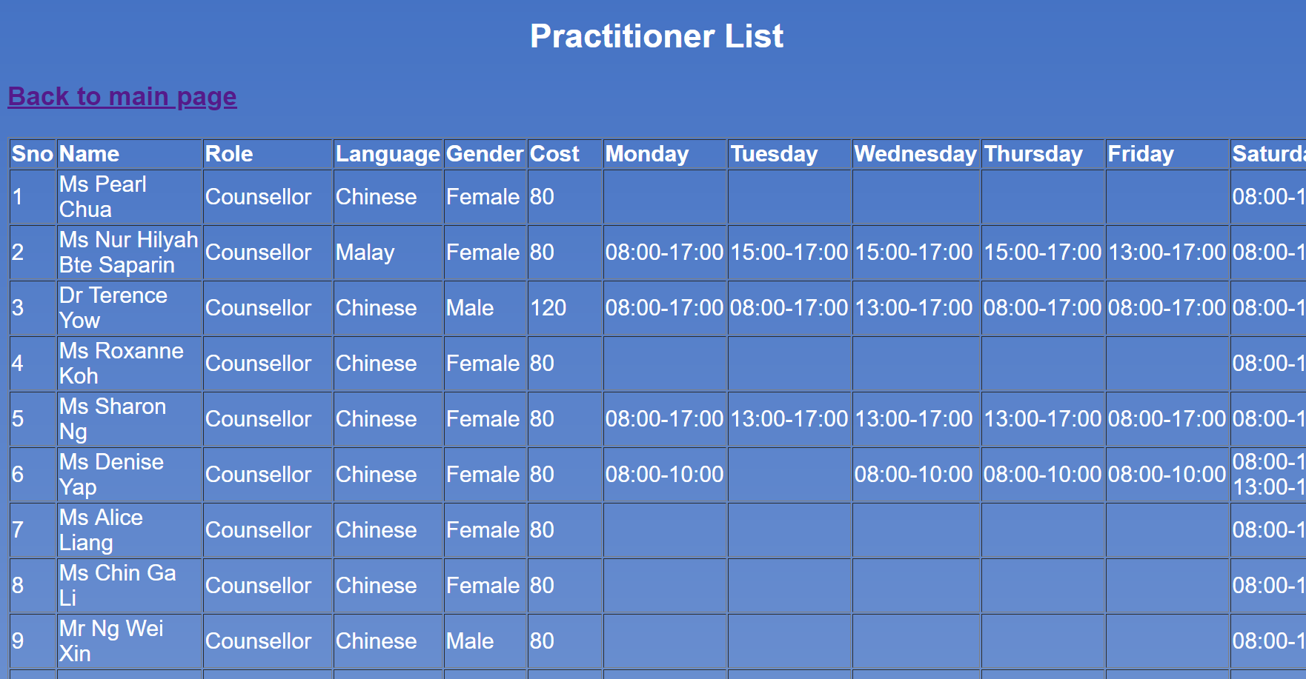

Matching patients to practitioners

Our system has two methods of matching patients to practitioners:

1. Click the “Go to Matching” option to start the process of matching existing patients to practitioners in the database
2. For users who have not screen for depression yet, click the “Start PHQ9 Screening” option to start the PHQ-9 screening process.

Start PHQ9 Screening

We will explain the scenario when users have not screen for depression yet. After clicking “Start PHQ9 Screening”, our system will guide users through the PHQ-9 depression screening in order to get the PHQ-9 score. We will skip details of the depression screening procedures as this information can be found in the “User Guide for Depression Screening System”.

At the end of the screening process, our system will display the PHQ-9 score. Users can choose to click “Go to practitioner appointment preference selection” to schedule an appointment with a practitioner who can help them with their depressive symptoms (see figure 4)

Figure 4. PHQ-9 score page

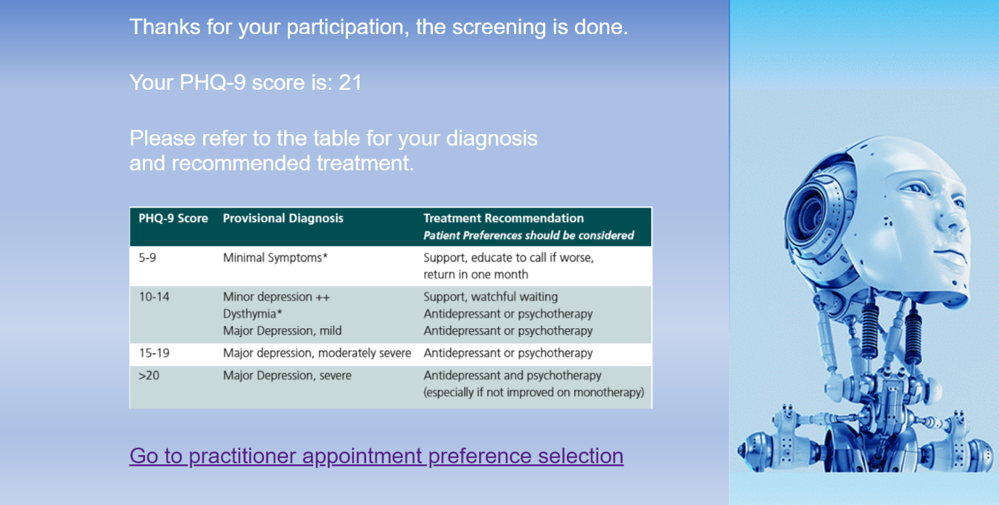

Patients’ preferences (see figure 5)

After clicking “Go to practitioner appointment preference selection”, our system will prompt users to submit the following information:

1. Practitioner Gender
2. Practitioner Role
3. Practitioner Language
4. Institution Location
5. Session Day

Figure 5. Patients’ preferences

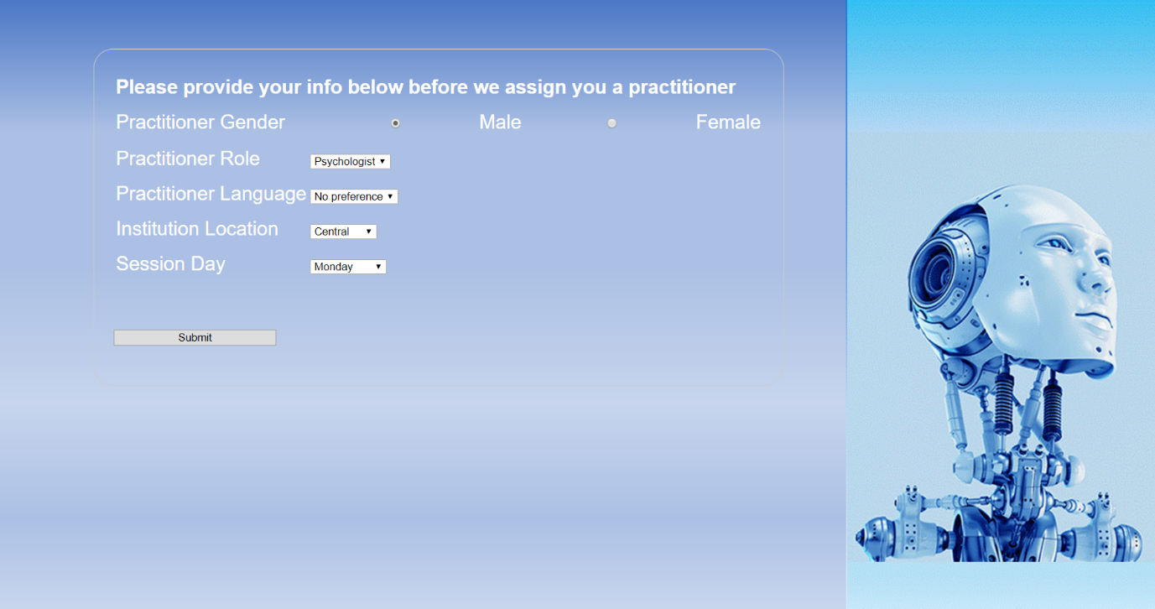

Saved preferences page (see figure 6)

After submitting their preferences, our system will save the information in the database and assigns the user with an id. At this point, users can click “Show Patients’ Data” to view the database records or click “Go to Matching” to get their appointments with the practitioners. Users can return to the main page at any time.

Figure 6. Saved preferences page

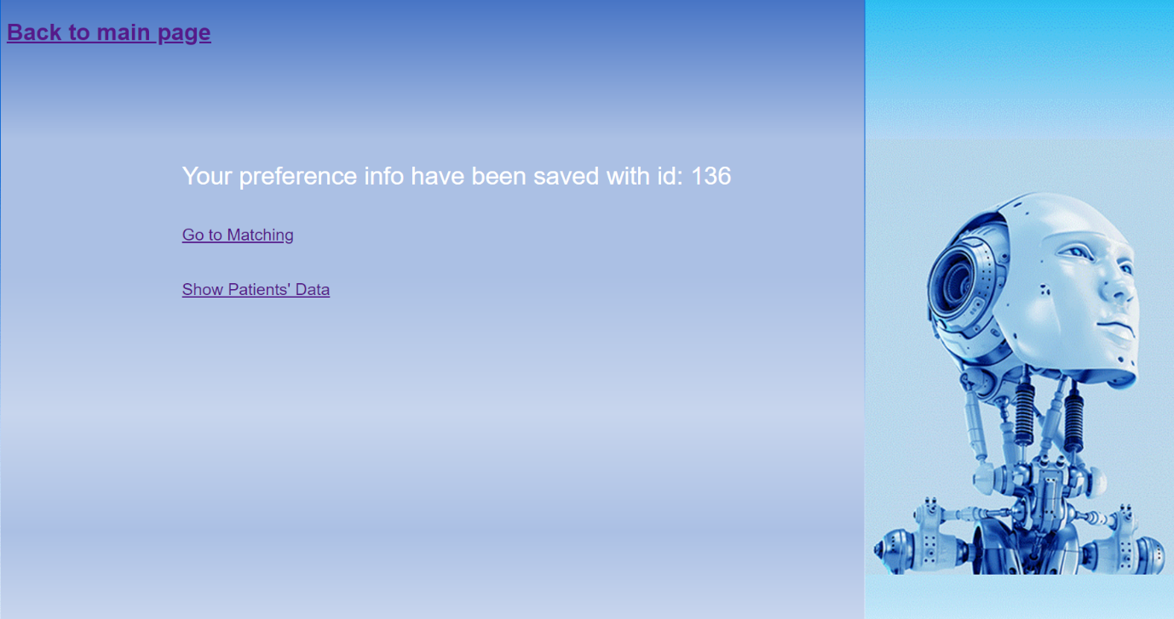

Go to Matching (see figure 7)

After clicking “Go to Matching”, our system will show the users the number of patients’ record and practitioners’ record in the database. Users can choose to return to the main page or click “Start Matching” start the matching of patients to practitioners.

Figure 7. The page after clicking “Go to Matching”

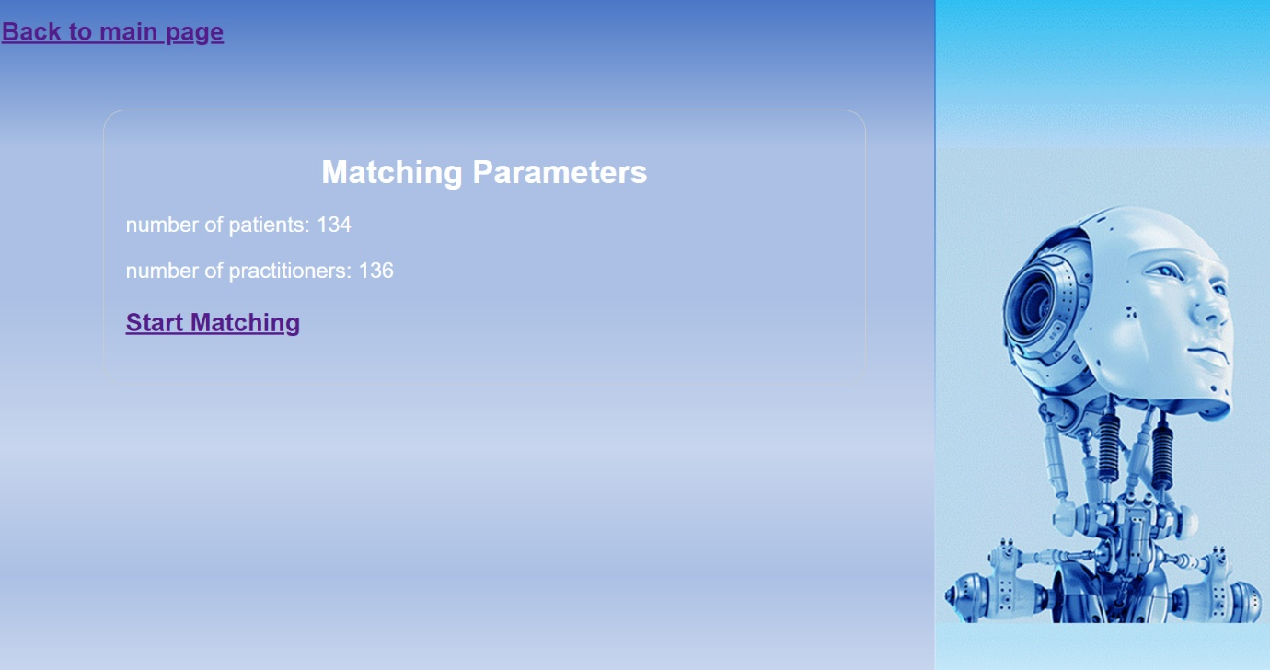

Loading page (see figure 8)

After clicking “Starting Matching”, our system will show the users a loading page while OptaPlanner is working in the background. We set the system to return the results after two minutes.

Figure 8. Loading page



Result page (see figure 9)

After two minutes, our system will display the following information for each matched pair of patient and practitioner:

1. Patient Name
2. PHQ-9 Score
3. Practitioner Name
4. Practitioner Role
5. Practitioner Language
6. Practitioner Gender
7. Session Day
8. Overall Location
9. Detail Location

The system also displays the scores for the hard and soft constrain as a measure of the performance of the optimization process. This will end the session. Users can return to the main page at any time.

Figure 9. Result page

